LAB NO: 8

LAB AIM: To implement Support Vector Machine (SVM) algorithm for classification.
DATASET AND RESOURCES : ai2020 dataset from classroom and Python/Jupyter Notebook

DATE OF PERFORMANCE:21 -10 -2026

GITHUB REPO LINK :
https://github.com/Prabhkirat-Singh-Marwah/ML-PRACTICALS/upload/main/Practical-08

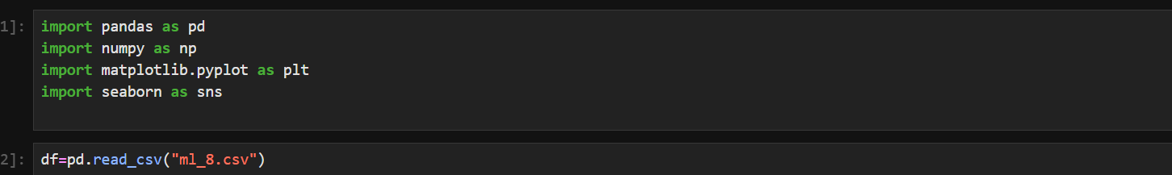
These command import the important libraries needed for basic data entries, cleaning and calculations, also the below command reads the dataset.

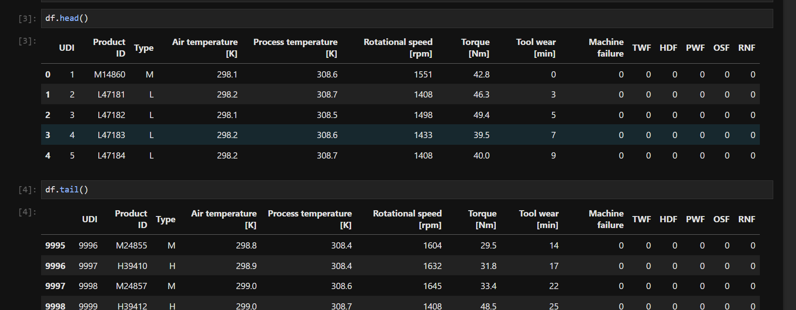
Df.head prints top 5 rows and df.tail prints bottom 5 rows of the dataset.

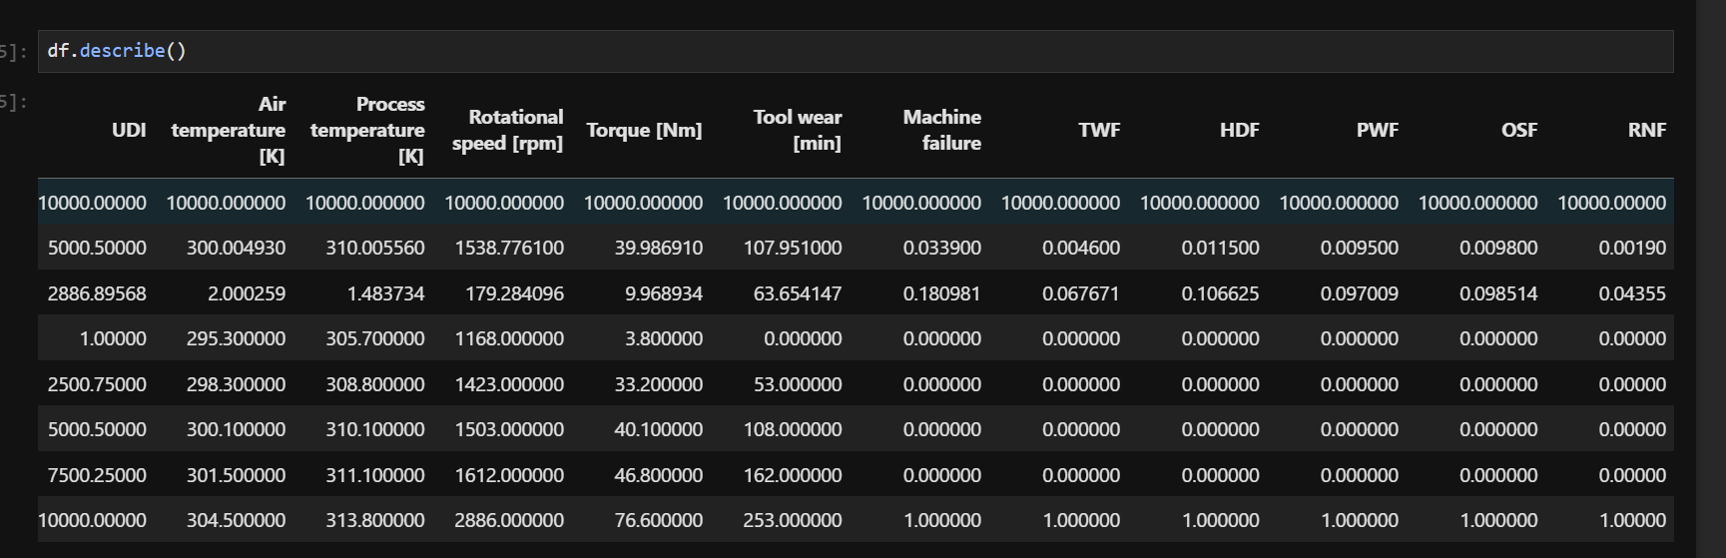
This command calculates basic mathematical and statistical values for the dataset.

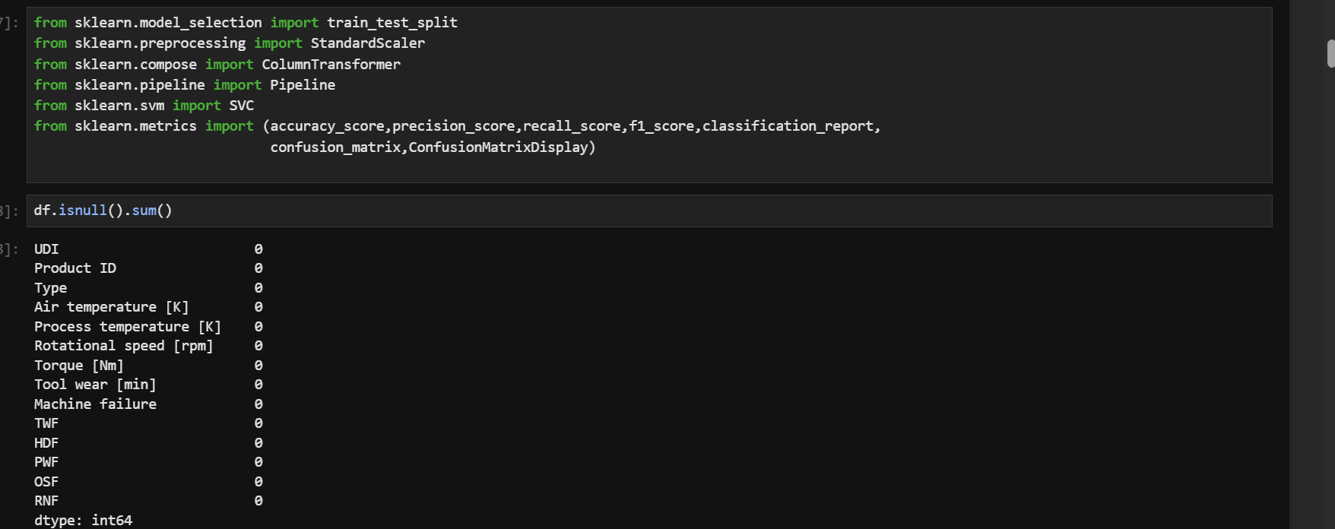this command import some libraries and also check if any null values exist in the dataset form each column present.

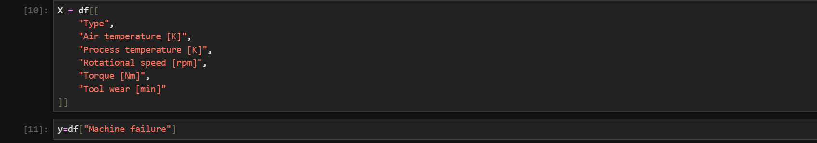
This command divides the dataset columns into two values where X is input columns and y is the output columns.

This command divides the dataset into two parts in ratio 80_20 for training and testing dataset respectively.

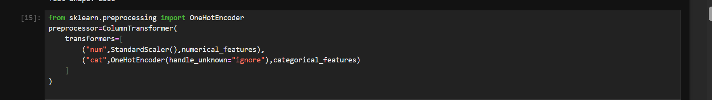
This command makes the numerical value into similar range and the alphabetical value into numerical values like 0 , 1 .

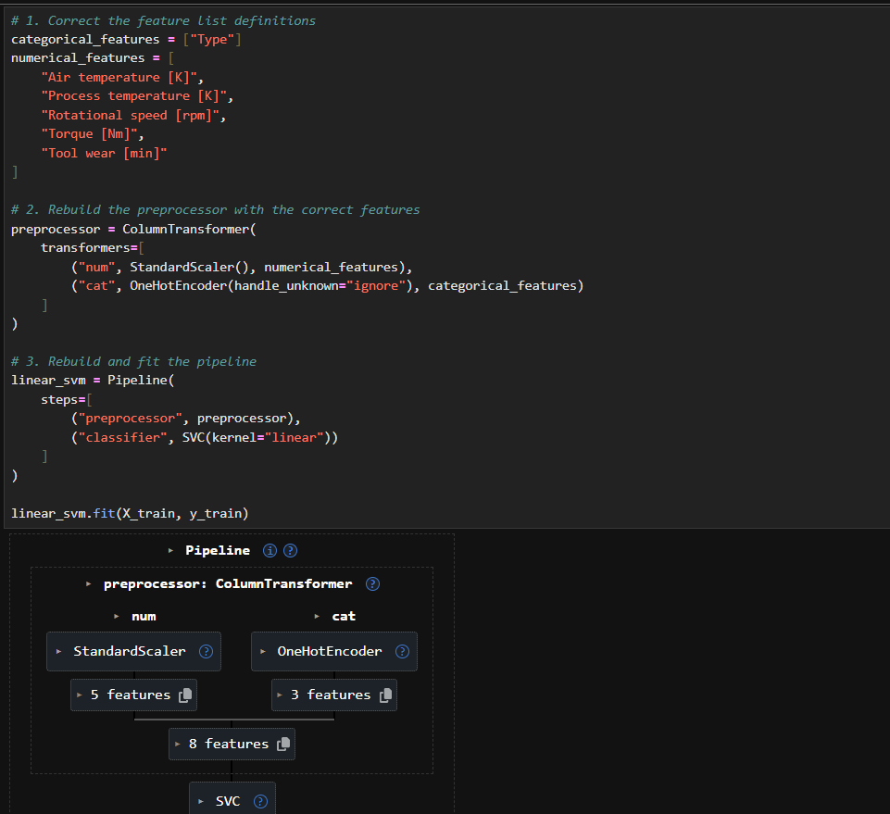
Builds the preprocessor again and joins it with a linear SVM in a pipeline. Then it trains the model on the training data.
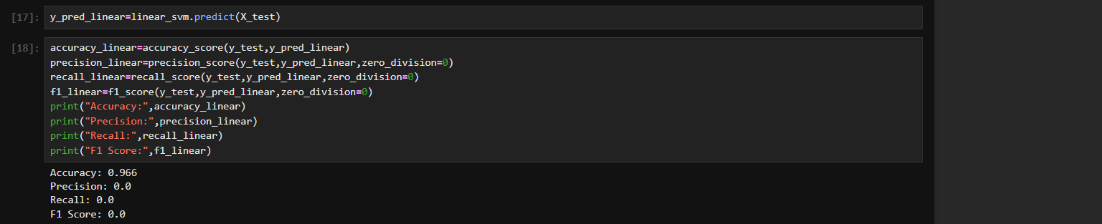
This command is used to train the model svm on dataset and then print values like precision, recall, f1 score for checking If the model is correct, overfitted or underfitted.

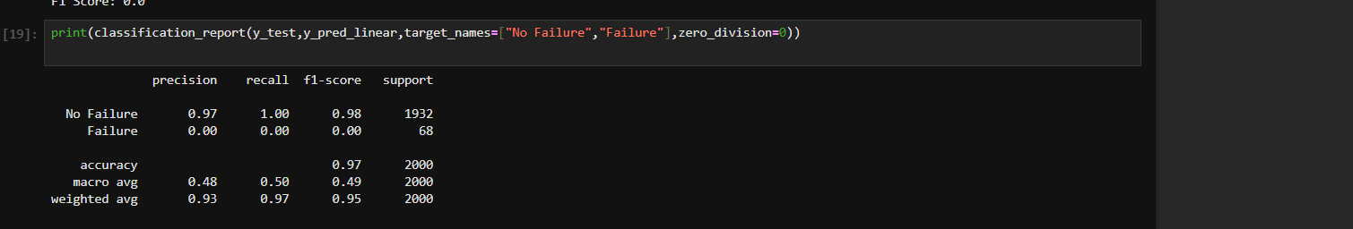
Prints a classification report, which shows the scores for “No Failure” and “Failure” separately

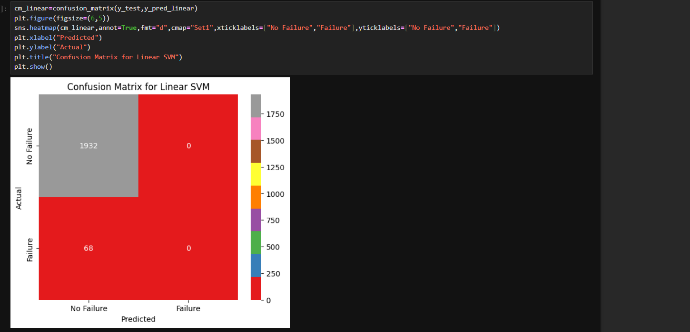
Draws a confusion matrix for the linear SVM, so we can see how many predictions were right and wrong.

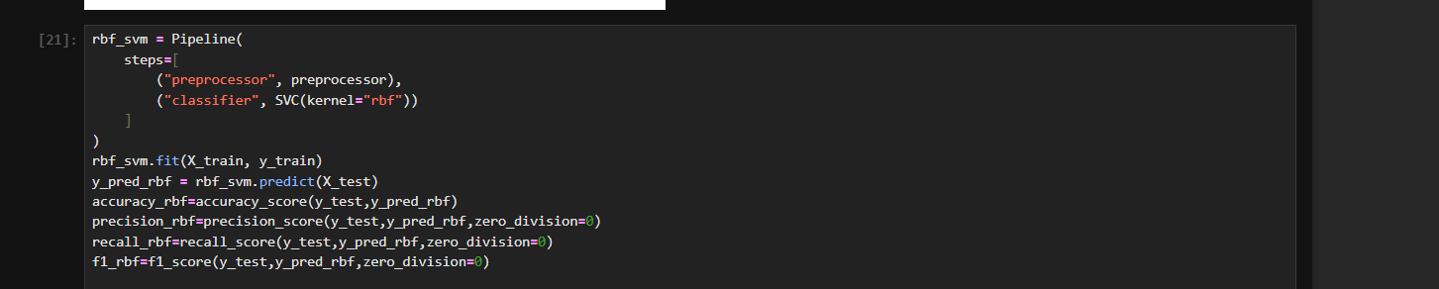
Builds and trains an RBF kernel SVM, then predicts on the test data. The last 4 lines save its scores, which we need later for the comparison table.

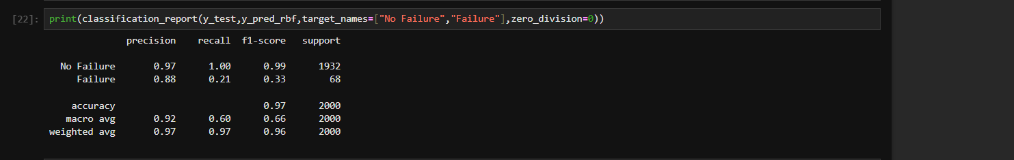
Prints the classification for rbf model ,

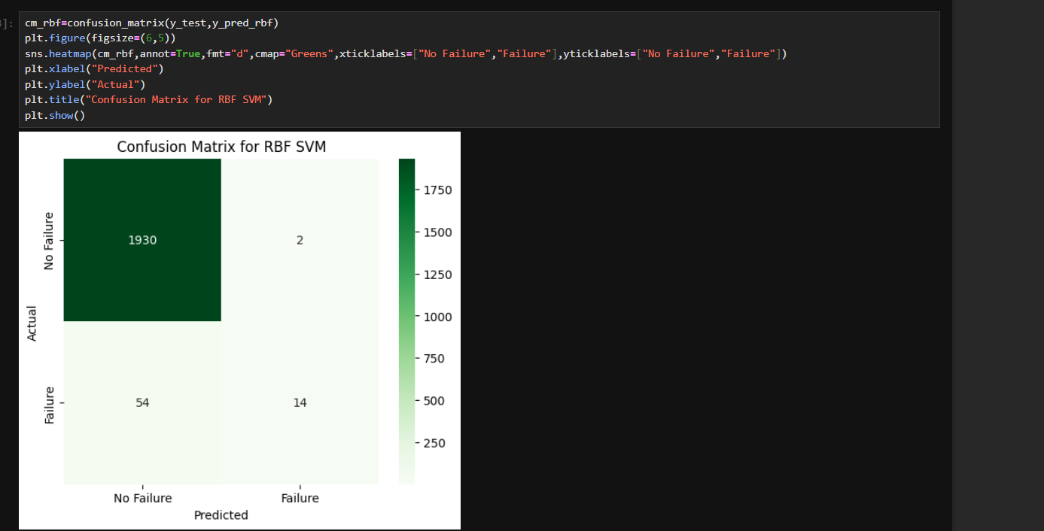
Prints the confusion matrix for rbf.

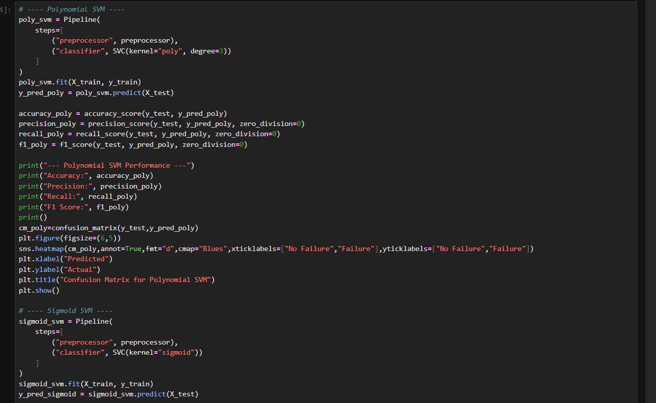
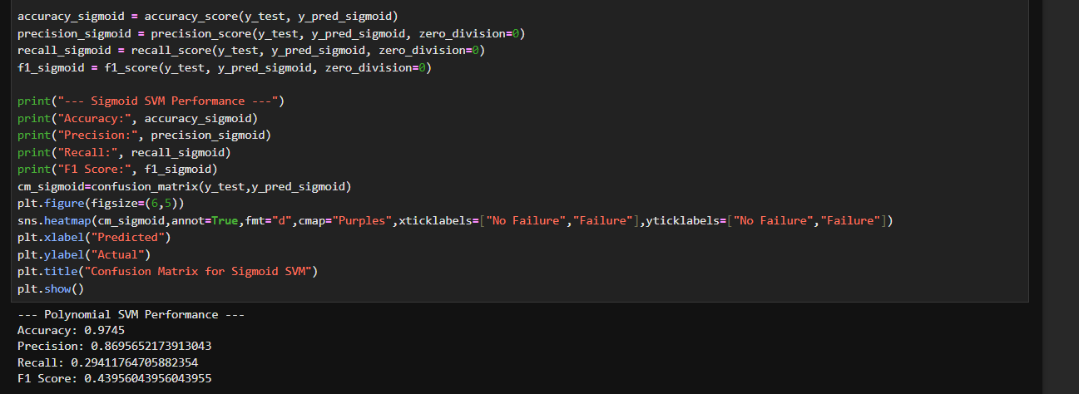
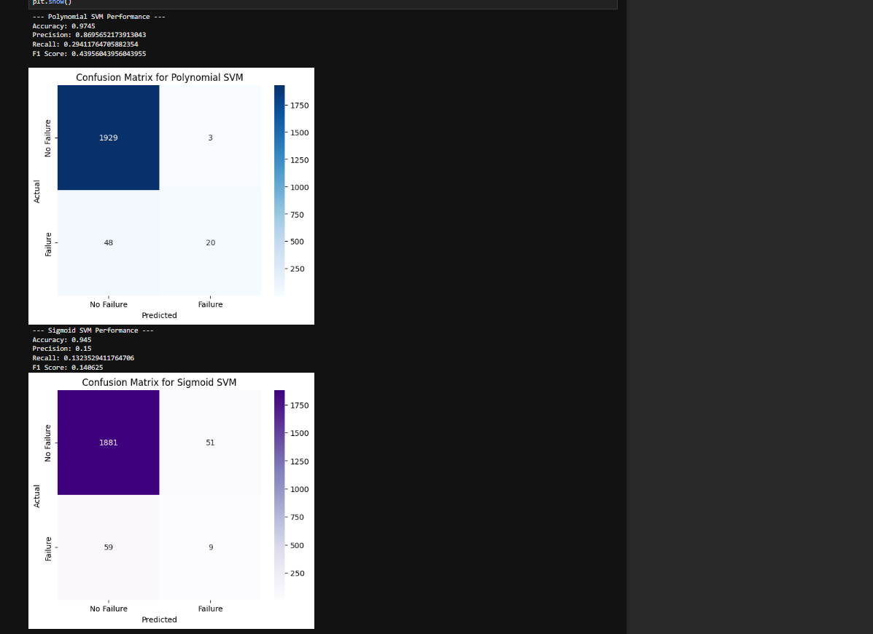
This command trains and prints the svm model using sigmoid and polynomial function and also prints the confusion matrix for each one.

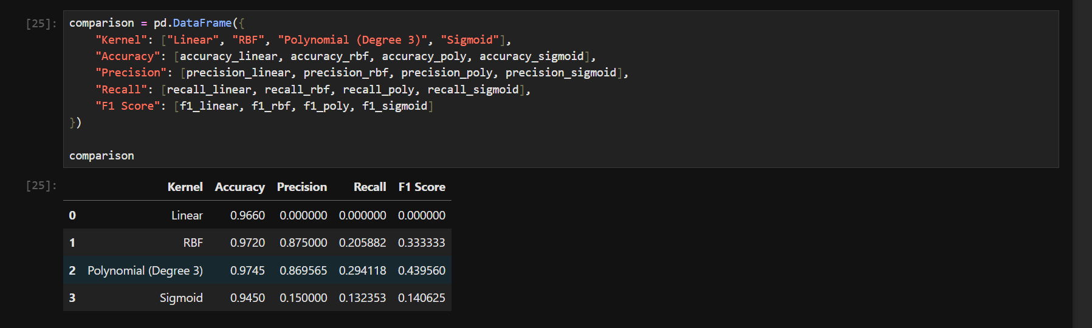
Makes a table that puts the scores of all 4 kernels side by side, so we can compare them easily.

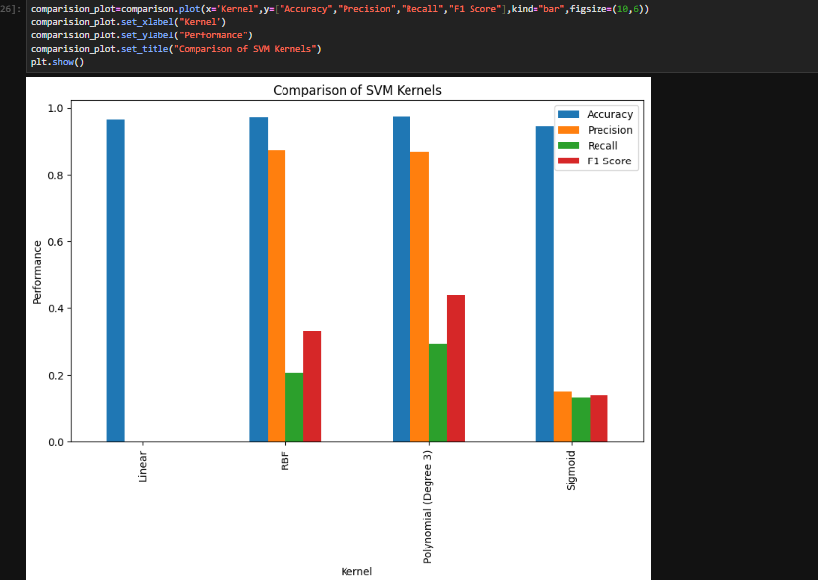\ Plots plots comparison table as a bar graph.

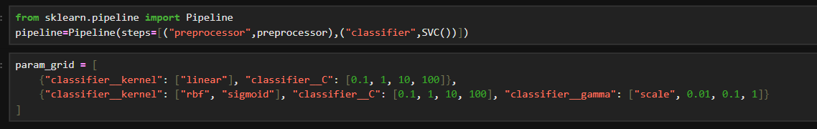
Makes a list of the settings we want to try, like different kernels, C values and gamma values.

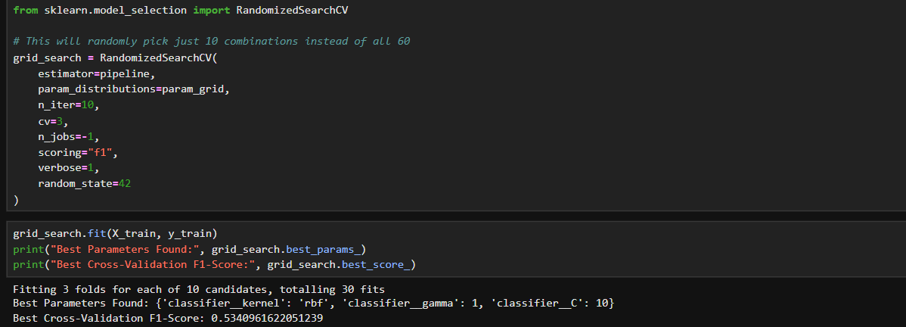
Runs the search on the training data and prints the best settings it found, along with the best F1 score.

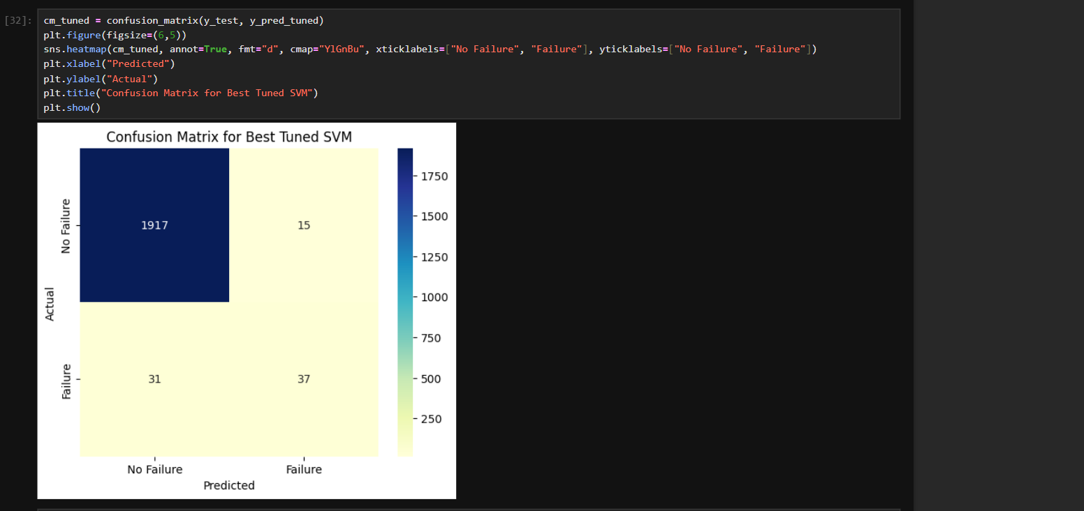
Prints the confusion matrix for best model post fine tuning

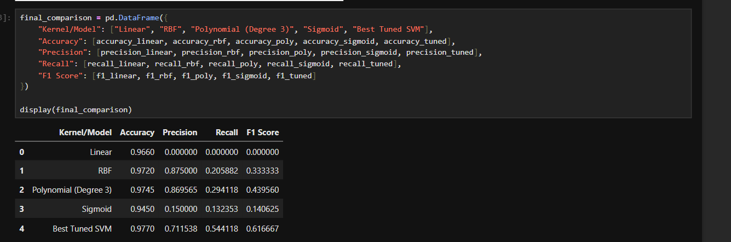
This command compares the values between all the models on metrics like f1 score, recall, precision and accuracy.

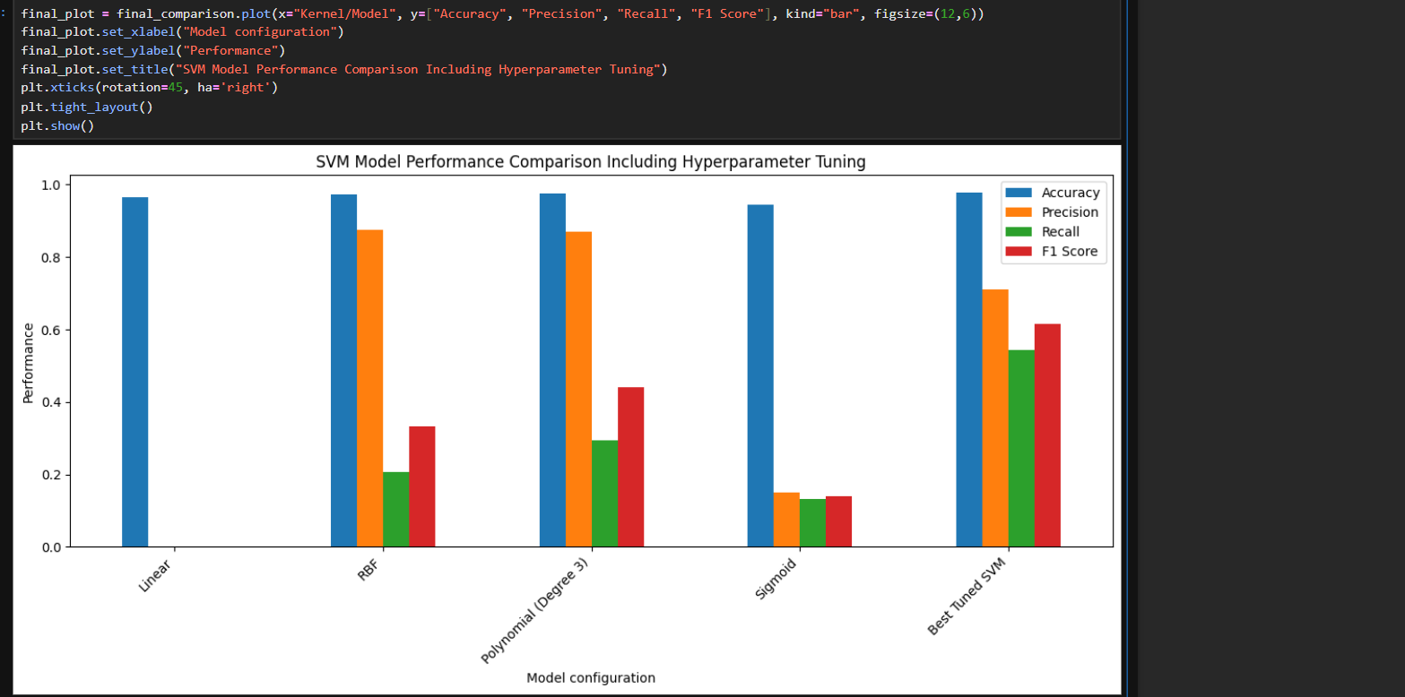
This command shows the same metrics as above but a visual representation of it instead of numbers .

VIVA QUESTIONS
Q1. Why did you use a Pipeline in this code?
Ans: A Pipeline joins the preprocessing (scaling and one-hot encoding) and the SVM model into one object. So when we call fit or predict, all the steps run in the right order automatically. It also stops data leakage, because the scaler learns only from the training data.
Q2. Why did you use StandardScaler and Encoder in the ColumnTransformer?
Ans: SVM works on distances, so numeric columns like temperature and rpm must be on the same scale, and StandardScaler does that. The Type column is text, so Encoder converts it into 0/1 columns that the model can understand.
Q3. What does stratify=y do in train_test_split?
Ans: Only a small part of the data (about 3.4%) is machine failure. stratify=y keeps the same failure percentage in both the train and test sets. Without it, the test set might get too few failure cases.
Q4. Why did the linear SVM give precision, recall and F1 as 0.0 even though accuracy was 0.966?
Ans: The data is imbalanced, so the linear SVM just predicted "No Failure" for every row. That is why accuracy looks high, but it never caught a single failure. This is why we check precision, recall and F1 and not only accuracy. Using class_weight="balanced" in SVC can help.
Q5. What is the difference between GridSearchCV and RandomizedSearchCV, and why did you use RandomizedSearchCV?
Ans: GridSearchCV tries every combination of the parameters, which takes a lot of time. RandomizedSearchCV tries only a fixed number of random combinations (n=10), so it is faster. I used cv=3 and scoring="f1" so the best model is chosen by F1 score, not accuracy.

